Chicago Bounce has elevated to one of the top clubs in Illinois. 4 teams in the Open Division at Nationals. Tops in the Northwest Suburbs

Why Bounce?

- Coach to player ratio – We are very proud of our coach to player ratio — 1 coach for every 6 players. By investing in our coaching staff, we ensure that our players get more individual attention and feedback thereby speeding their improvement.
- Experience – The program is owned and operated by collegiate level coaches and utilizes area high school and junior high coaches. Our staff has experience playing and coaching volleyball at a high level.
- Training the “all-around player” – We prepare every single athlete for success in multiple positions. By avoiding specialization at a young age, our athletes can transition to numerous positions at the next level without dealing with a learning curve.
- Volleyball IQ – We don’t just coach players on what to do and where to go. We help them understand the “why,” creating stronger, smarter athletes.
- Communication and organization – We pride ourselves in 100% transparency with parents and players. We continually communicate throughout the year to make sure that parents are in the loop on everything; from tournaments and practices to playing time and strategy.
- Consistency – We have consistent practice times and locations. No week to week carpool scrambling.

REGISTER TODAY
www.chicagobouncevolleyball.com
Questions? Blake Orlov, Club Director
info@chicagobouncevolleyball.com / 847-791-1020

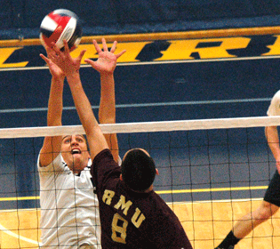

AGES
Tryouts are open to boys from 5th to 12th grade

DATES AND TIMES
September 6
Grades 4-9: 6-7:30 PM
Grades 10-12: 8-9:30 PM

September 7
Grades 4-9: 6-7:30 PM
Grades 10-12: 8-9:30 PM

LOCATION
Joy of the Game
158 S. Waukegan Rd.
Deerfield, IL

COST
$30 (covers both days)

PLAY HARD… HAVE FUN

